**Exercise 1:Cricketapp**

**Code:**

**File:App.js**

import React, { useState } from "react";

import ListofPlayers from "./components/ListofPlayers";

import IndianPlayers from "./components/IndianPlayers";

function App*()* {

  const [flag, setFlag] = useState(true); // toggle between components

  return (

    <div className="App">

      <h1>Welcome to Cricket App</h1>

      <button onClick={*()* => setFlag(!flag)}>

        Show {flag ? "Indian Players" : "List of Players"}

      </button>

      <hr />

      {flag ? <ListofPlayers /> : <IndianPlayers />}

    </div>

  );

}

export default App;

**File:ListofPlayers.js**

import React from "react";

const ListofPlayers = *()* => {

  const players = [

    { name: "Virat Kohli", score: 85 },

    { name: "Rohit Sharma", score: 95 },

    { name: "Hardik Pandya", score: 68 },

    { name: "Shubman Gill", score: 74 },

    { name: "KL Rahul", score: 55 },

    { name: "Ravindra Jadeja", score: 90 },

    { name: "Jasprit Bumrah", score: 45 },

    { name: "Suryakumar Yadav", score: 77 },

    { name: "Mohammed Siraj", score: 64 },

    { name: "Shreyas Iyer", score: 81 },

    { name: "Rishabh Pant", score: 59 },

  ];

  const lowScorers = players.filter(player => player.score < 70);

  return (

    <div>

      <h2>All Players:</h2>

      <ul>

        {players.map(*(player, index)* => (

          <li key={index}>

            {player.name} - {player.score}

          </li>

        ))}

      </ul>

      <h2>Players with Score below 70:</h2>

      <ul>

        {lowScorers.map(*(player, index)* => (

          <li key={index}>

            {player.name} - {player.score}

          </li>

        ))}

      </ul>

    </div>

  );

};

export default ListofPlayers;

**File:IndianPlayers.js**

import React from "react";

const IndianPlayers = *()* => {

  const oddTeam = ["Virat", "Hardik", "KL Rahul", "Bumrah", "Siraj"];

  const evenTeam = ["Rohit", "Gill", "Jadeja", "SKY", "Iyer", "Pant"];

  // Destructuring Odd Team

  const [odd1, odd2, ...oddRest] = oddTeam;

  const [even1, even2, ...evenRest] = evenTeam;

  const T20players = ["Kohli", "Rohit", "SKY", "Bumrah"];

  const RanjiTrophyPlayers = ["Pujara", "Rahane", "Unadkat"];

  const allPlayers = [...T20players, ...RanjiTrophyPlayers]; // ES6 merge

  return (

    <div>

      <h2>Odd Team Players:</h2>

      <ul>

        <li>{odd1}</li>

        <li>{odd2}</li>

        {oddRest.map(*(player, index)* => (

          <li key={index}>{player}</li>

        ))}

      </ul>

      <h2>Even Team Players:</h2>

      <ul>

        <li>{even1}</li>

        <li>{even2}</li>

        {evenRest.map(*(player, index)* => (

          <li key={index}>{player}</li>

        ))}

      </ul>

      <h2>All Players (T20 + Ranji Trophy):</h2>

      <ul>

        {allPlayers.map(*(player, index)* => (

          <li key={index}>{player}</li>

        ))}

      </ul>

    </div>

  );

};

export default IndianPlayers;

**Output:**

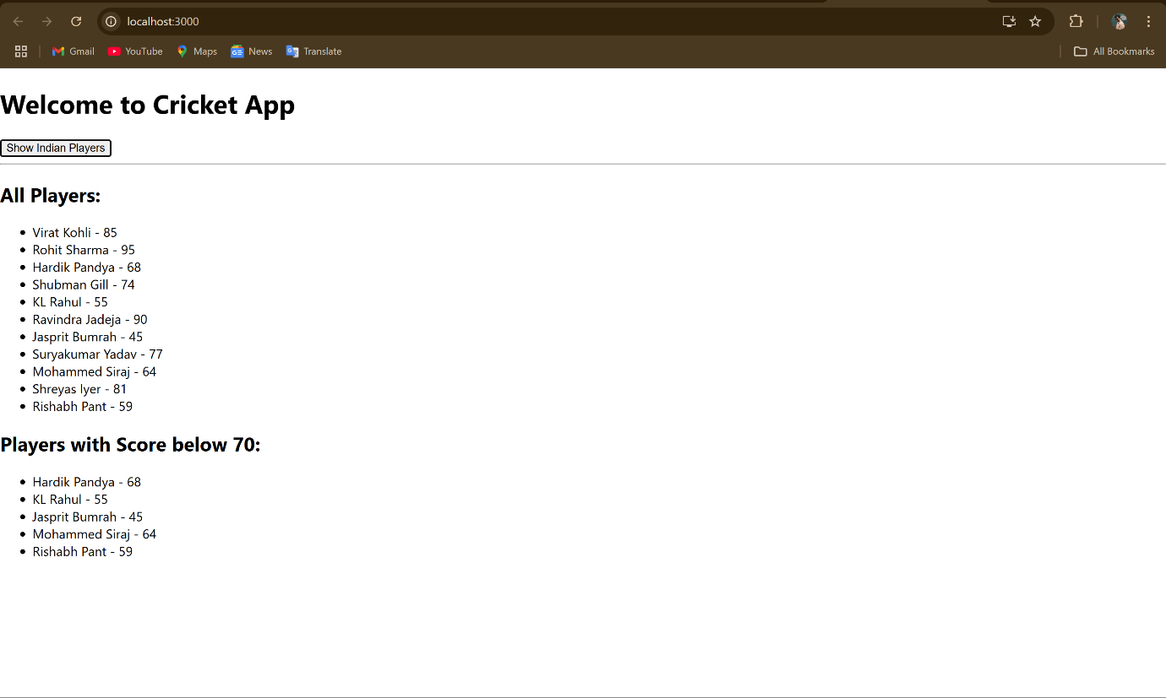

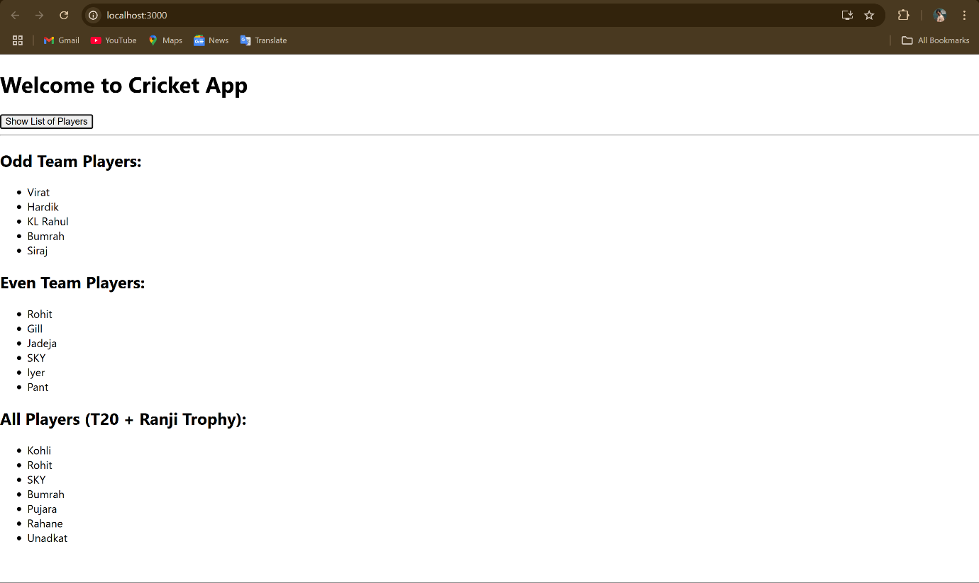

**Exercise 2: Officespacerentalapp**

**Code:**

**File:App.js**

import React from "react";

import "./App.css";

function App*()*{

  const officeList =[

    {

      id :1,

      name: "Tech Park View",

      rent: 50000,

      address : "123 Tech Lane,Bangaluru",

      image : "https://images.unsplash.com/photo-1507679799987-c73779587ccf?auto=format&fit=crop&w=800&q=60"

    },

    {

      id: 2,

      name: 'Corporate Hub',

      rent: 75000,

      address: '456 Business Bay, Mumbai',

      image: 'https://images.unsplash.com/photo-1573164713988-8665fc963095?auto=format&fit=crop&w=800&q=60',

    },

    {

      id: 3,

      name: 'Startup Studio',

      rent: 45000,

      address: '789 Innovation Street, Pune',

      image: 'https://images.unsplash.com/photo-1600585154340-be6161a56a0c?auto=format&fit=crop&w=800&q=80',

    },

  ];

  return (

    <div className="App">

      <h1>Office Space At Affordable Range</h1>

      {officeList.map(*(office)* =>(

        <div key = {office.id} className="office-card">

          <img src={office.image} alt={office.name}/>

          <h2>{office.name}</h2>

          <p>Address: {office.address}</p>

          <p className={office.rent<60000 ? "low-rent":"high-rent"}>

            Rent: Rs. {office.rent.toLocaleString()}

          </p>

        </div>

      ))}

    </div>

  )

}

export default App;

**File:App.css**

.low-rent {

  color: red;

  font-weight: bold;

}

.high-rent {

  color: green;

  font-weight: bold;

}

.App {

  text-align: center;

  font-family: Arial, sans-serif;

  padding: 20px;

}

**Output:**



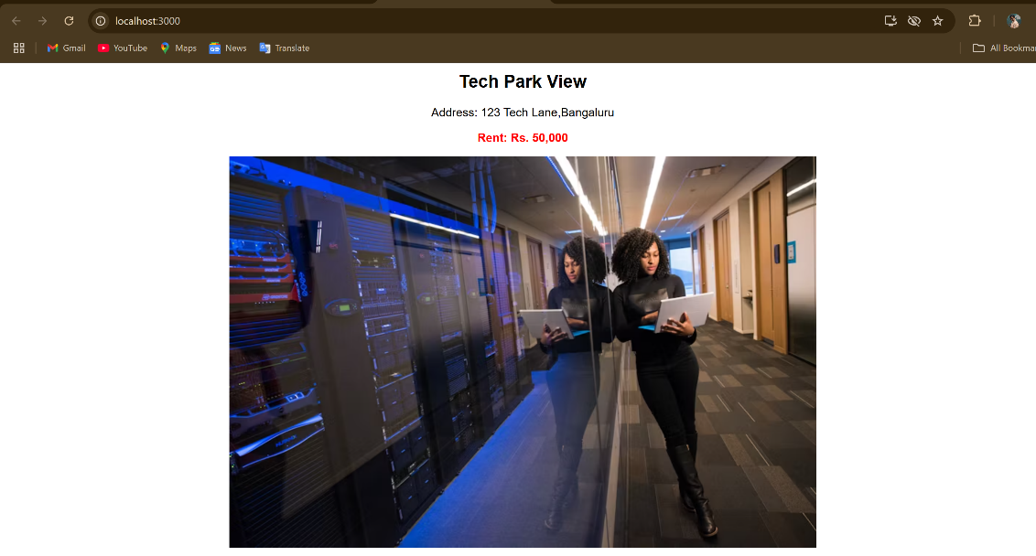

**Exercise 3:Eventexamplesapp**

**Code:**

**File:App.js**

import React,{useState} from "react";

import CurrencyConvertor from "./components/CurrencyConvertor";

function App*()* {

  const [counter, setCounter] = useState(0);

  const incrementCounter = *()* => {

    setCounter(prev=>prev+1);

    sayHello();

  };

  const decrementCounter = *()*=>{

    setCounter(prev=>prev-1);

  };

  const sayHello = *()*=>{

    console.log("Hello!This is an increment event");

  };

  const sayWelcome = *(message)* => {

    alert(message);

  };

  const handleSyntheticClick = *(event)* => {

    console.log("I was clicked!");

    alert("I was clicked!");

  };

  return(

    <div className="App">

      <h1>Event Examples App</h1>

      <div>

        <h2>Counter: {counter}</h2>

        <button onClick={incrementCounter}>Increment</button>

        <button onClick={decrementCounter}>Decrement</button>

      </div>

      <div style={{marginTop: "20px"}}>

        <button onClick={*()*=>sayWelcome("Welcome!")}>Say Welcome</button>

      </div>

      <div style = {{marginTop: "20px"}}>

        <button onClick={handleSyntheticClick}>OnPress</button>

      </div>

      <div style={{marginTop: "30px"}}>

        <CurrencyConvertor/>

      </div>

    </div>

  )

}

export default App;

**File:src/components/CurrencyConverter.js**

import React, {useState}  from "react";

function CurrencyConvertor*()*{

    const [rupees, setRupees] = useState('');

    const [euro, setEuro] = useState(null);

    const handleChange = *(event)*=>{

        setRupees(event.target.value);

    };

    const handleSubmit = *()*=>{

        if(!rupees || isNaN(rupees)){

            alert("Please enter a valid number");

            return;

        }

        const conversionRate = 0.011; // Example conversion rate from INR to Euro

        const convertedEuro = (rupees * conversionRate).toFixed(2);

        setEuro(convertedEuro);

    };

    return(

        <div>

            <h1>Currency Convertor (INR to Euro)</h1>

            <input type="number" value={rupees} onChange={handleChange} placeholder="Enter INR amount"/>

            <button onClick={handleSubmit}>Convert</button>

            {euro !== null && <p>{euro} Euro</p>}

        </div>

    );

}

export default CurrencyConvertor;

**Output:**

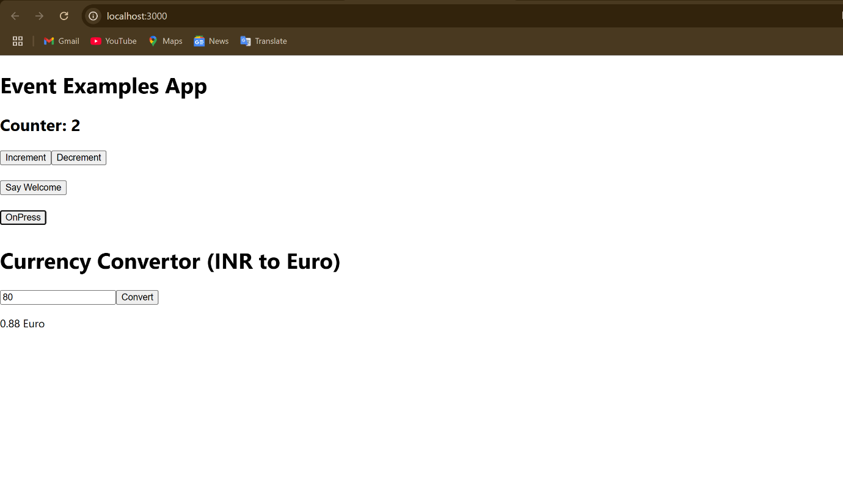

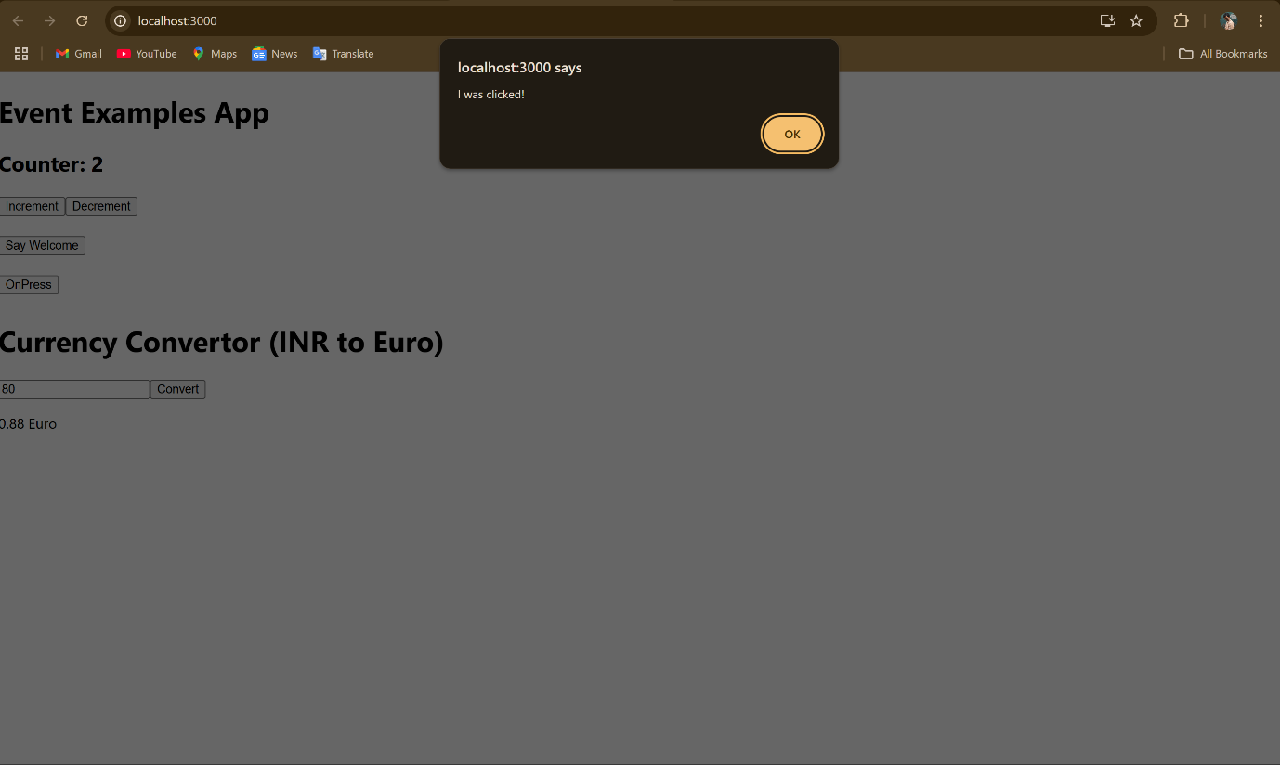

**Exercise 4:TicketBookingApp**

**Code:**

**File:**